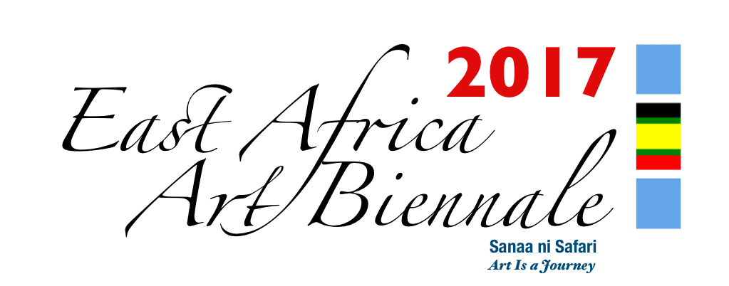
East Africa Art Biennale Association
Nafasi Art Space
Eyasi Road, Mikocheni
P.O BOX 23165
Dar Es Salaam, TANZANIA
Phone: +255 768 222 011/+255 713 975 784

APPLICATION FORM: EAST AFRICA ART BIENNALE 2017

POLICY STATEMENT
Each artist is allowed to submit to the Organizing Committee a minimum of two (2) and a maximum of five (5) artworks. The East Africa Art Biennale will accept submissions to exhibit paintings, sculptures, print works, conceptual and contextual works, installations, video art, textile and fiber art, drawing and calligraphy, pattern, hair style art, digital art, ceramic art, fashion, glass art, contextual art, and art photography. Artworks should be recent (not more than 2 years old), preferably not yet exhibited.
The Organising Committee (OC) has established sub-committees (or antennas) in the East African countries other than Tanzania, with the purpose of acting as an intermediate between the Organising Committee and the local artists and organisations.

Every individual artist or group of artists from East Africa can participate to EASTAFAB 2017, and there is no participation fee to pay; artists from regions other than East Africa can also participate in the Biennale free of charge.
Once the East African applicants have been notified that their applications have been accepted, they should drop their works to the designated local EASTAFAB National Committee for shipping to EASTAFAB, Dar-es-Salaam, Tanzania.
Artists from out of East Africa who have been approved will have to ship their artworks by their own means directly or via their intermediates (Gallery, Embassy etc) to the ESTAFAB National Committee; ESTAFAB will be responsible to return the artworks to the artists or their intermediates.

Each participant, whether an individual artist or group of artists, or gallery, will have to fill a participation form providing all necessary information in English or Kiswahili about himself/herself and the artworks proposed to EASTAFAB, and send it by normal post, e-mail or fax not later than April 30th, 2017. A copyright release is part of the application form. Should new artworks be completed after April 30th the applicant could still send the image of the artwork, but not later than May 31st 2017

The approved artworks should be sent by the participant himself/herself directly to the designated local EASTAFAB National Committee not later than June 30st, 2017; prior to sending the approved artworks, contact should be taken with EASTAFAB as to the best mode to send the artworks.

It is the editorial decision of the Organising Committee to assess which artworks are suitable for the Catalogue, and this depends on the space made available.

At the end of the EASTAFAB exhibition, the unsold artworks will be returned to the artists by the Organising Committee in Dar-es-Salaam, Tanzania, via the sub-committees in the other East African countries, for their final restitution to the respective artists.

Artists will indicate in the application form if the artworks are for sale or not and if they are for sale indicate the price in TZS or USD at which artwork can be bought. The artists will get 80% of the sales of his/her artwork. The remaining 20% will be charged as the administrative cost.

The unsold artworks by participating artists from countries out of East Africa will be returned to the artists by the Organising Committee in Dar-es-Salaam by all appropriate means and within reasonable time.

The EASTAFAB Organising Committee will consider the possibility of attributing honorary prizes under the following categories: EASTAFAB 2017 First, Second and Third Prizes, EASTAFAB 2017 Public Choice, EASTAFAB 2017 Media Choice, ESTAFAB Sponsors’ Choice.
Read carefully the Policy statement attached to the application form.
Your Application must include:
- Artist Signature
- All the required information
- Artist biography and statement
- Artist portrait digital photograph
- Digital photos of the proposed artworks
PERSONAL DETAILS
First Name |  | Home Address:
Last Name |  | City:
Gender (M or F)
Phone:  Mobile: |  | Country of Residence:
Age: |  | Nationality:
Email: |  | Date of Birth
Personal Website: |  | Links or other Websites

Description of the artworks submitted for selection
 | Title | Media & Size | Price in USD or TZS
1
2
3
4
5

Important – Please indicate if you have rights of any of your submitted artworks.
Artist Statement (max 60 words)

Biography (max 50 words)

Sending files
Send digital file to:
If large file transfer to Dropbox:
By Post for heavy videos, with registered parcel or express mail to:
The undersigned hereby releases the copyright of my artworks submitted to the biennale, for the use in the biennale catalogue and other forms of biennale publications (press release, press notes, advertisement, billboards, etc) that will be found suitable by the organising committee for the promotion of the EASTAFAB Association.
The artwork that might get damaged or lost under EASTAFAB possession might be reimbursed.
I hereby agree to the policies, terms and conditions of the East Africa Art Biennale.
Artist’s name: _______________________________ Date: _________________________
Artist’s signature: ____________________________

